

**MATHEMATICS METHODS 3**

**SEMESTER 1 2018**

**INVESTIGATION 1**

**The significant *e***

**Marks: 40 Time: 45 minutes**

You know **π** is an irrational number. The number ***e*** is also an irrational number. The letter ***e*** honours the Swiss mathematician Leonard Euler (1707–1783). Euler also developed the symbol **π**. He was the first to use the symbol ***i*** to represent imaginary numbers (not part of our Course).

In this investigation, you will develop a deeper understanding of the significance of ***e***.

**e** can be found on your keyboard of your Classpad by entering e1.

**1. *e* as a limit. [1, 1, 4, 1, 3, 3 marks]**

a) Write the value of e correct to 5 decimal places.

2.71828 ✓

Consider the function f(x) = (1 + )x

b) We say that $\lim_{x→∞}{{\left(1+\frac{1}{x}\right)}^{x}}$ = e.

Explain what this means in words.

As x increases to an infinitely large value, f(x) will approximate e. ✓

c) Complete the following table, correct to 5 decimal places:

|  |  |
| --- | --- |
| x | (1 + )x |
| 1 | 2 |
| 2 | 2.25 |
| 3 | 2.37037 |
| 4 | 2.44141 |
| 10 | 2.59374 |
| 20 | 2.65330 |
| 50 | 2.69159 |
| 100 | 2.70481 |
| 1 000 | 2.71692 |
| 1 000 000 | 2.71828 |

½ per correctly rounded answer

d) Write your observations here.

As x increases the value approaches e. ✓

e) Plot y = (1 + )x below for x $≥$ 0. Do this on your Classpad first.

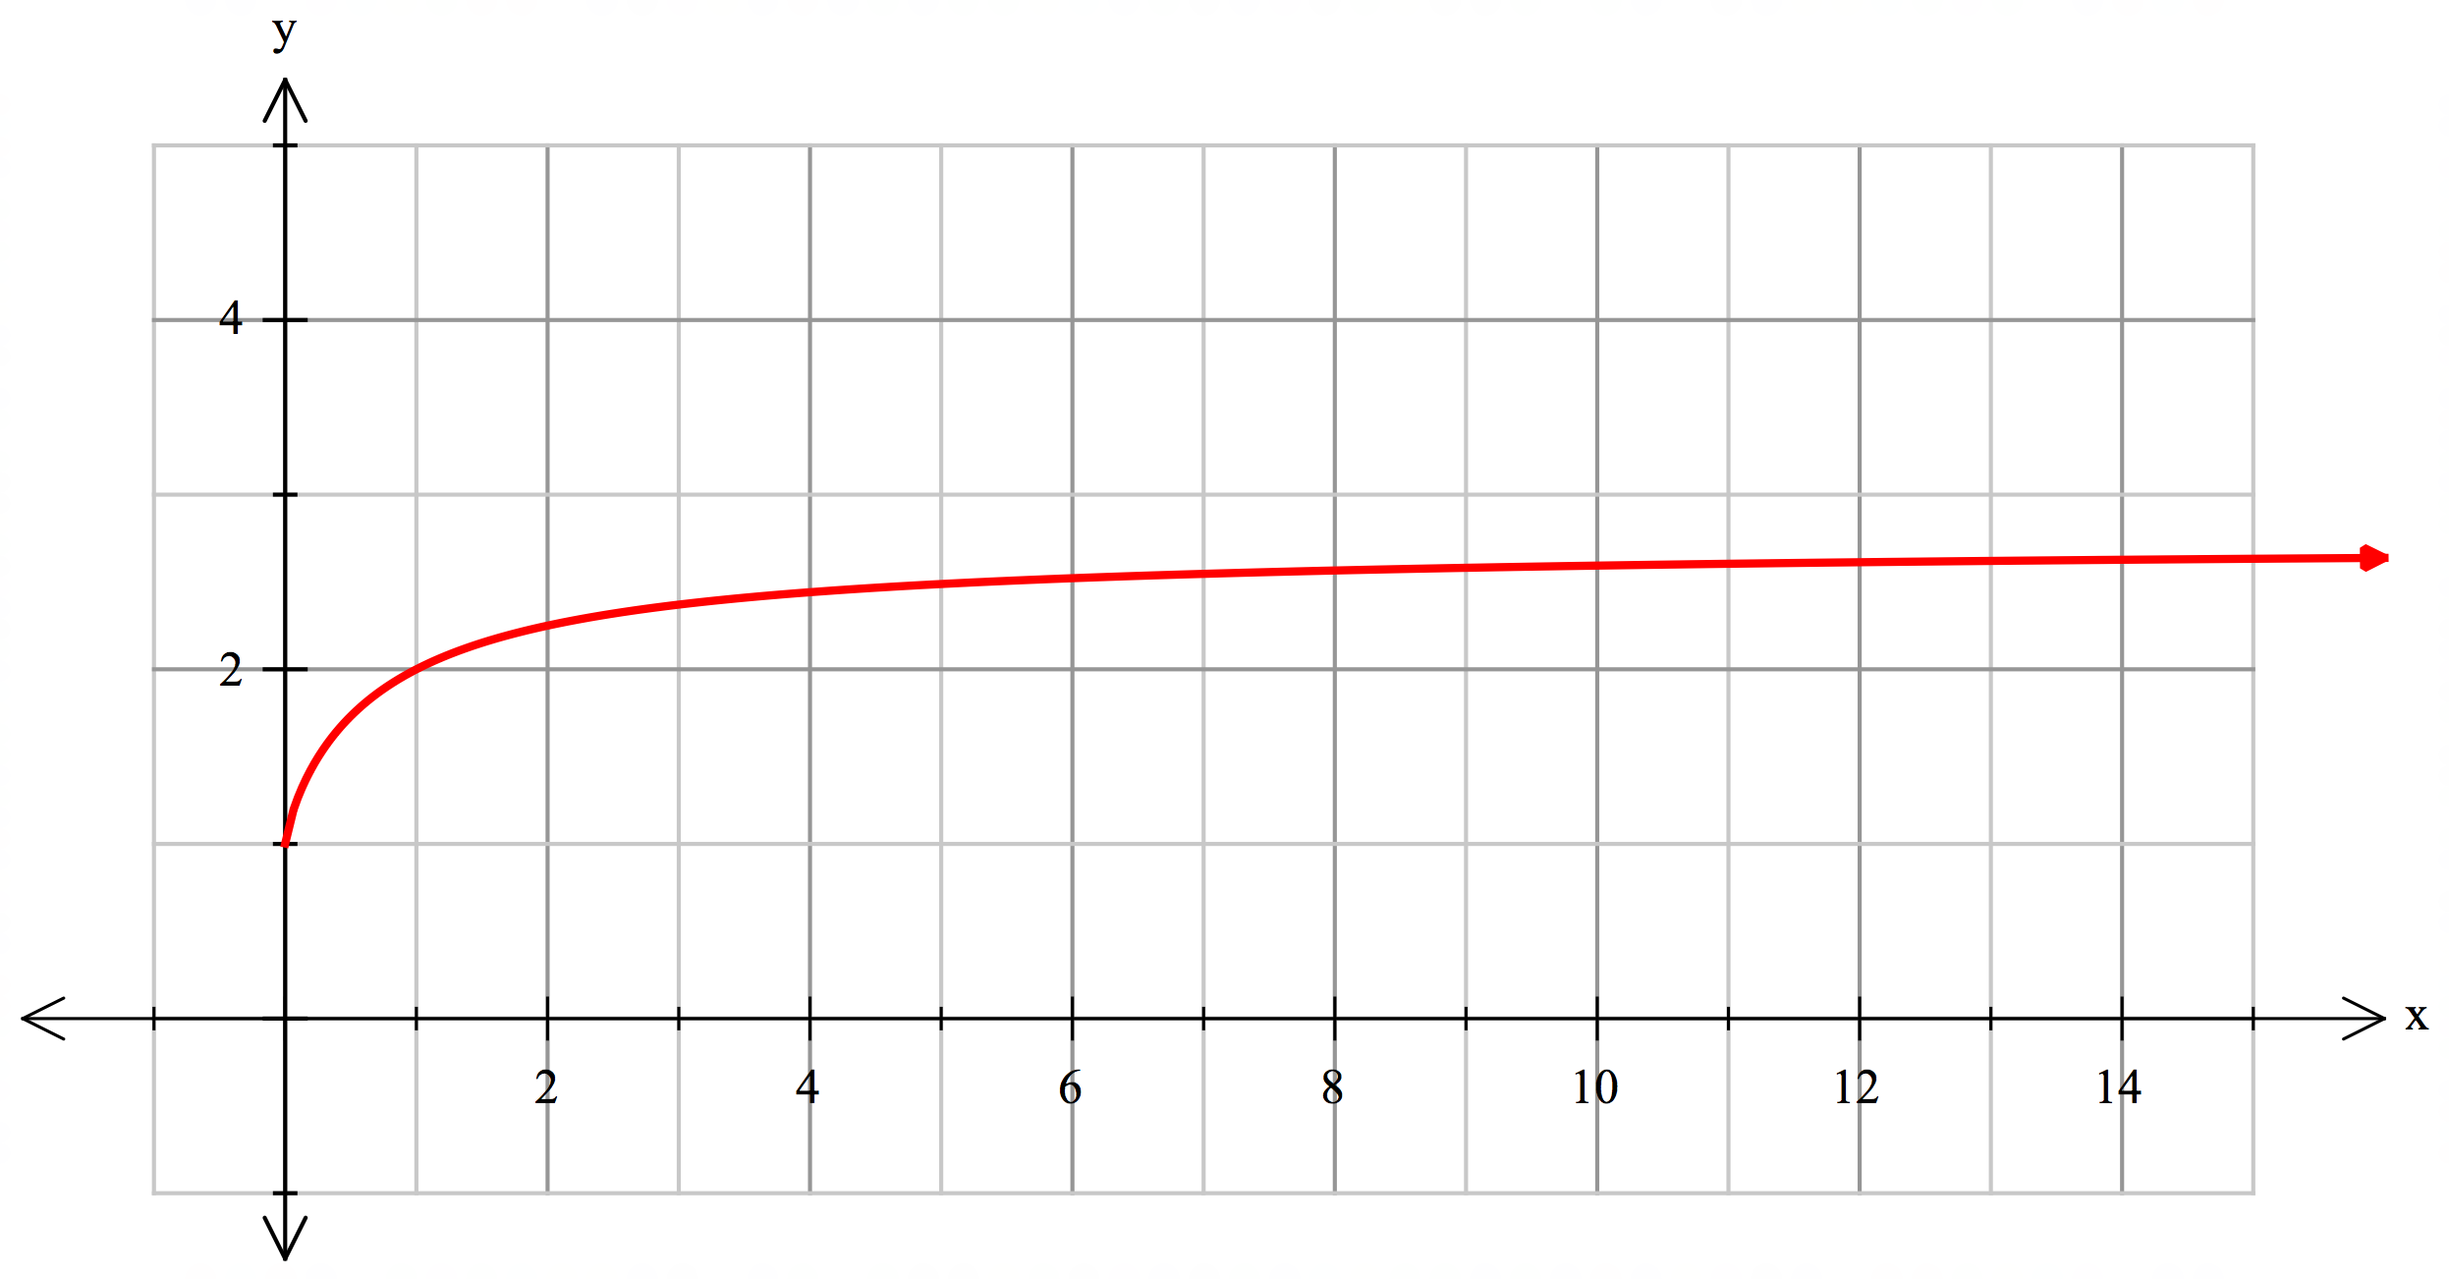

Indicates x $≠$ 0 ✓        Indicates asymptote at y = e ✓✓  

f) Write three observations about the curve. ✓✓✓

Discontinuous at x = 0

There is an asymptote at y = e

Comment regarding range 0 < y < e

Comment regarding slope being positive but approaching zero

**2. Another way of looking at *e* [4, 2 marks]**

Another way of defining *e* is:



a) Complete the table below to get an approximate value for *e* correct to 5 decimal places.

Note : in maths n! (pronounced “n factorial” ) means



e.g. 5! = 5.4.3.2.1 = 120 (you can use your Classpad to do this)

|  |  |
| --- | --- |
| **n** | **Total (approximation for *e*)** |
| 1 |  |
| 2 |  |
| 3 | 2.5 |
| 4 | 2.66667 |
| 5 | 2.70833 |
| 6 | 2.71667 |
| 7 | 2.71786 |
| 8 | 2.71801 |
| 9 | 2.71802 |
| 10 | 2.71802 |

½ per answer …….6 – 10 require full working.

b) Write this as a limit as n

+ + ……………….+ ✓✓

**3. Another limit………. [1, 4, 2 marks]**

Use your Classpad to create the graph of f(x) = ${(1+x)}^{\frac{1}{x}}$

1. You will notice that there is no value of f(x) when x = 0. Explain why.

For the power 1/x, x cannot be zero. ✓

1. You can approximate this value by approaching x = 0 and determining the approximate value. Complete this table to determine an approximation of the function when x = 0. Round to 5 decimal places.

Note: Use a graph created on the Classpad to do this!

|  |  |  |  |  |
| --- | --- | --- | --- | --- |
| x | f(x) |  | x | f(x) |
| 0.5 | 2.25 |  | -0.5 | 4 |
| 0.1 | 2.59374 |  | -0.1 | 2.86797 |
| 0.01 | 2.70481 |  | -0.01 | 2.73120 |
| 0.001 | 2.71692 |  | -0.001 | 2.71964 |
| 0.0001 | 2.21815 |  | -0.0001 | 2.71842 |
| 0.00001 | 2.71827 |  | -0.00001 | 2.71830 |

Maximum of 4 marks …deduct ½ per error

1. Remembering that we say that $\lim_{x→∞}{{\left(1+\frac{1}{x}\right)}^{x}}$ = e, write a definition of e based on the table above.

$\lim_{n→0}{{\left(1+n\right)}^{\frac{1}{n}}}$ = e ✓✓

**4. An application of e [1, 2, 4 marks]**

Many bridges have arches that resemble a parabola but are not quite parabolic. This kind of shape is called a catenary curve. You can make a catenary curve by holding a piece of rope by both ends, one end in each hand, and let the rope swing freely. One model for a catenary curve is

f(x) = $\frac{a}{2}(e^{\frac{x}{a}}+ e^{-\frac{x}{a}}$) where *a* is a real, non-zero constant.

1. Let a = 2. Write the equation of the curve.

f(x) = $(e^{\frac{x}{2}}+ e^{-\frac{x}{2}}$) ✓

b) Plot this equation on your Classpad and sketch below.

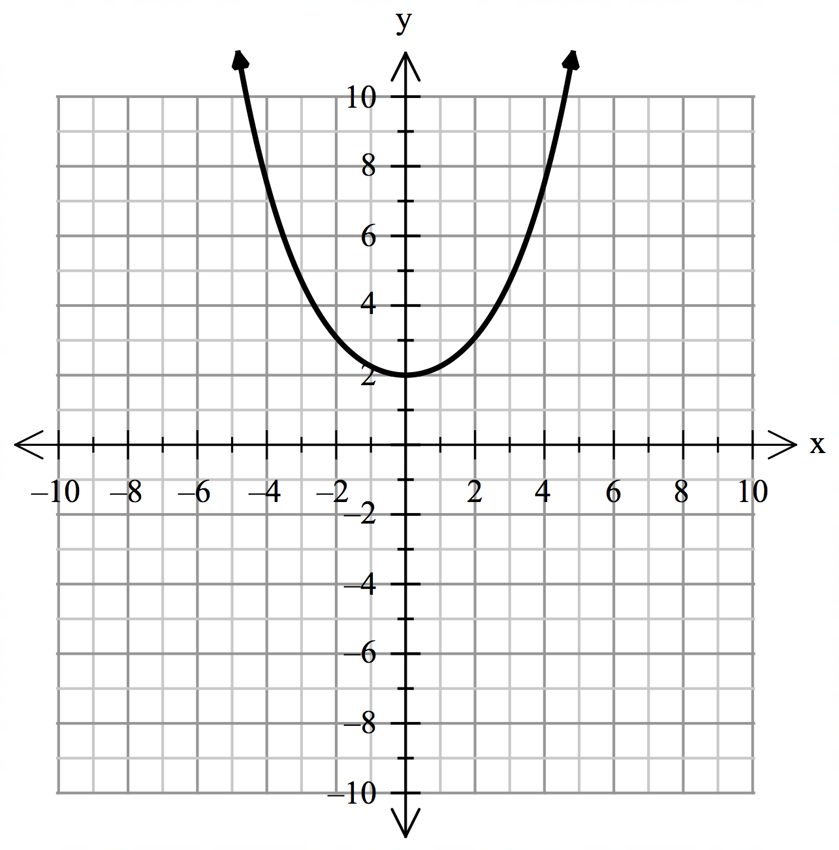

Turning point at (0, 2) ✓

Evidence of using other points such as

(2,3.09) or (4, 7.52) ✓

c) Determine the function g(x), which is parabolic and approximates this curve. Working is required here, and you should describe what you did to find this function.

Using a table of values in Statistics and applying quadratic regession

y = 0.355x + 1.801

Table ✓✓    Equation ✓✓  

Assuming minimum is (0, 2) then

y = ax2 + 2    ✓

Using (2, 3.09) ✓

a = 0.2725 ✓

y = 0.2725x2 + 2 ✓

**5. Another application. [4, 2, 1 marks]**

When compound interest is determined we would use A = P(1 + r)n, where A is the amount returned after the time period, P is the Principal, r is the rate as a decimal and n is the number of times that interest is credited.

Assume $100 is invested at 10% pa interest credited annually,

After 1 year the A = $110

If the interest is credited quarterly this will be

A = 100(1 + )4 = $110.38

We divide the rate by 4 as it is now quarterly and raise this to the power of 4 because interest is credited 4 times.

1. Determine what A would be if interest was credited monthly and daily.

A = 100(1 + )12 = $110.47 ✓✓

A = 100(1 + )365 = $110.52 ✓✓

1. If interest was calculated continuously, what would A be? Explain your reasoning.

$110.52 ✓

As the time period gets shorter, we reach a limit …..in this case 110.52 ✓

c) What is the value of A if it was written in terms of e?

100 e0.1 ✓